COLLEGE CODE: 9513
COLLEGE NAME: Jayaraj Annapackiam CSI College of Engineering
DEPARTMENT: Computer Science and Engineering
STUDENT NM-ID: 10BCDE93819A0098EDF4A5BC4B86836F
ROLL NO: 951323104037
DATE: 06.10.2025

Completed the project name as
Interview Buddy – AI Powered Interview Preparation Bot (A Single Page Application)

SUBMITTED BY,
NAME: PRIYA.S
MOBILE NO: 7010311130

PHASE 5
ABSTRACT
The “Interview Buddy” project is an AI-powered mock interview simulator developed using React.js. It allows users to practice interview questions interactively and receive instant feedback. The system randomizes questions, tracks answers, and calculates performance metrics to help users evaluate their readiness for interviews.

OBJECTIVES

- To simulate a real interview environment.
- To evaluate user performance with instant scoring.
- To provide a clean, user-friendly interface.
- To help students prepare confidently for interviews.

TECHNOLOGIES USED

Technology Purpose
React.js Frontend framework
HTML, CSS UI design
JavaScript (ES6) Logic and state handling
useState, useEffect React hooks for state management
Node.js Runtime environment
SYSTEM DESIGN
Flow Diagram:
- Home → Mock Interview → Feedback
Data Flow: User → selects section → attempts questions → gets feedback.

MODULES
Home: Introduction section displaying the project purpose.
Mock Interview: Displays random MCQs and records user answers. Feedback: Shows performance report and score percentage.

RESULTS
The app successfully displays randomized questions, provides real-time feedback, and calculates the user’s final score accurately. It is responsive and suitable for both desktop and mobile devices.

CHALLENGES & RESOLUTIONS

Challenge Resolution
Randomizing question order Implemented custom shuffleArray() function.
Managing multiple state updates Used React’s useState effectively. Component rendering delay Added conditional loading text.
Navigation limits Disabled buttons at first and last question.

FUTURE ENHANCEMENTS
- Add AI-generated personalized feedback.
- Integrate voice-based interview simulation.
- Add question categories and difficulty levels.
- Store user scores in a database.

CONCLUSION

This project successfully demonstrates a modern React-based application for mock interview preparation. It enhances confidence, improves readiness, and provides an engaging experience for students and job seekers.

CODE:

Index.js
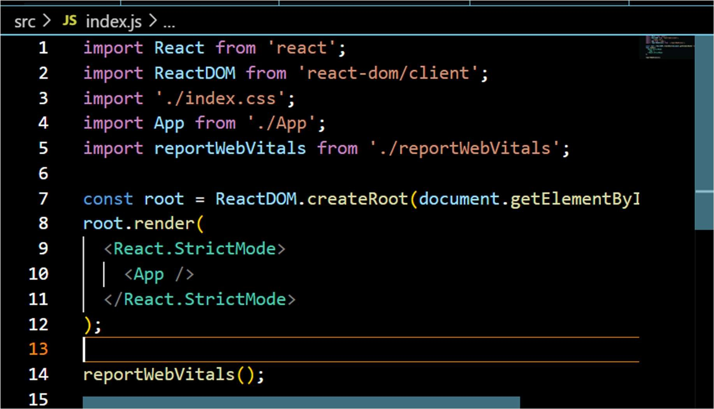

App.js:

import React, { useState, useEffect } from "react"; import "./App.css";

// Shuffle function for questions only function shuffleArray(array) {
const newArr = [...array];
for (let i = newArr.length - 1; i > 0; i--) {
const j = Math.floor(Math.random() * (i + 1)); [newArr[i], newArr[j]] = [newArr[j], newArr[i]];
}
return newArr;
}

function App() {
const [activeSection, setActiveSection] = useState("home");
const [questions, setQuestions] = useState([]); const [currentQ, setCurrentQ] = useState(0); const [selectedOptions, setSelectedOptions] = useState([]);
const [scores, setScores] = useState([]);

// Original questions with options in order const originalQuestions = [
{
question: "Which of the following is a good way to introduce yourself?",
options: [
"Talk only about hobbies",
"Briefly summarize your background and strengths",

"Explain your entire life story", "Just say your name and stop",
],
correctIndex: 1,
},
{
question: "What should you focus on while answering 'Why this company?'",
options: [
"The company’s reputation and your alignment with its values",
"Salary only",
"That you just need any job", "That you live nearby",
],
correctIndex: 0,
},
{
question: "What is a good way to discuss your weaknesses?",
options: [
"Say you have no weaknesses", "Mention a weakness and how you're
improving it",
"Complain about your boss", "Avoid the question",
],
correctIndex: 1,
},
{
question: "How should you answer technical questions?",
options: [

"By panicking",
"By giving clear, structured explanations", "By ignoring the question",
"By saying you forgot everything",
],
correctIndex: 1,
},
{
question:
"What should you do if you don’t know the answer to a question?",
options: [
"Make up something unrelated",
"Admit you don’t know and explain how you'd find the answer",
"Stay silent",
"Blame your college",
],
correctIndex: 1,
},
];

// Shuffle questions only useEffect(() => {
const shuffledQs = shuffleArray(originalQuestions);
setQuestions(shuffledQs); setSelectedOptions(Array(shuffledQs.length).fill(
null));
setScores(Array(shuffledQs.length).fill(null)); setCurrentQ(0);
// eslint-disable-next-line react-hooks/exhaustive- deps

}, []);

const handleOptionSelect = (index) => { if (questions.length === 0) return;
const updatedSelected = [...selectedOptions]; updatedSelected[currentQ] = index; setSelectedOptions(updatedSelected);

const updatedScores = [...scores]; updatedScores[currentQ] =
index === questions[currentQ].correctIndex ? 1 :
0;
setScores(updatedScores);
};

const Home = () => (
<div className="section">
<h1>·_*˘⬛'’ Interview Buddy</h1>
<p className="tagline">AI Powered Interview Preparation Bot</p>
<p>
Practice MCQ interview questions with randomized order of questions!
</p>
</div>
);

const MockInterview = () => {
if (questions.length === 0) return <p>Loading questions...</p>;
const current = questions[currentQ];

return (
<div className="section">
<h2>•!3 Mock Interview</h2>
<p className="question">
<strong>Q{currentQ + 1}:</strong>
{current.question}
</p>

<div className="options">
{current.options.map((option, i) => (
<label key={i} className="option-item">
<input type="radio"
name={`question-${currentQ}`} checked={selectedOptions[currentQ] ===
i}
onChange={() => handleOptionSelect(i)}
/>
{option}
</label>
))}
</div>

{scores[currentQ] !== null && (
<p className="score-display">
{scores[currentQ] === 1 ? "⬛ Correct!" : "+ Wrong Answer"}
</p>
)}

<div className="button-group">
<button

className="primary-btn"
onClick={() => setCurrentQ((prev) => (prev
> 0 ? prev - 1 : prev))}
disabled={currentQ === 0}
>
Previous
</button>
<button className="primary-btn" onClick={() => setCurrentQ((prev) =>
prev < questions.length - 1 ? prev + 1 :
prev
)
}
disabled={currentQ === questions.length -
1}
>
Next
</button>
</div>
</div>
);
};

const Feedback = () => {
const answered = scores.filter((s) => s !== null); const total = answered.reduce((a, b) => a + b, 0); const totalQuestions = questions.length;
const percentage = totalQuestions
? ((total / totalQuestions) * 100).toFixed(1)
: 0;

return (
<div className="section">
<h2>)긎‘¸•긑굿긍 Feedback Summary</h2>
<p>
Questions Attempted:
{answered.length}/{totalQuestions}
</p>
<p>Correct Answers: {total}</p>
<p>Score Percentage: {percentage}%</p>
</div>
);
};

return (
<div className="app-container">
<nav className="navbar">
<div className="logo">Interview Buddy</div>
<div className="nav-links">
<button
className={activeSection === "home" ? "active" : ""}
onClick={() => setActiveSection("home")}
>
Home
</button>
<button
className={activeSection === "mock" ? "active" : ""}
onClick={() => setActiveSection("mock")}
>
Mock Interview

</button>
<button
className={activeSection === "feedback" ? "active" : ""}
onClick={() => setActiveSection("feedback")}
>
Feedback
</button>
</div>
</nav>

<div className="content">
{activeSection === "home" && <Home />}
{activeSection === "mock" &&
<MockInterview />}
{activeSection === "feedback" && <Feedback
/>}
</div>
</div>
);
}

export default App; App.css:
body {
font-family: "Segoe UI", Tahoma, Geneva, Verdana, sans-serif;
margin: 0;
background: linear-gradient(to right, #a1c4fd, #c2e9fb);

min-height: 100vh;
}

.app-container { max-width: 700px; margin: 0 auto; padding: 20px;
}

.navbar { display: flex;
justify-content: space-between; align-items: center; background-color: #1e3c72; color: white;
padding: 12px 20px; border-radius: 8px;
box-shadow: 0 4px 8px rgba(0, 0, 0, 0.2);
}

.navbar .logo { font-weight: bold; font-size: 1.3rem;
}

.nav-links button { background: transparent; border: none;
color: white; margin-left: 12px; cursor: pointer; font-weight: bold; font-size: 1rem;

transition: transform 0.2s;
}

.nav-links button:hover { transform: scale(1.05);
}

.nav-links button.active { text-decoration: underline;
}

.section {
background-color: #ffffffcc; padding: 25px;
margin-top: 25px; border-radius: 12px;
box-shadow: 0 6px 12px rgba(0, 0, 0, 0.15);
}

.question {
font-size: 1.2rem; font-weight: 500; margin-bottom: 15px; color: #1e3c72;
}

.options { display: flex;
flex-direction: column; margin-bottom: 15px;
}

.option-item {
margin: 8px 0; cursor: pointer; padding: 8px 12px; border-radius: 6px;
transition: background 0.2s, transform 0.1s;
}

.option-item:hover { background-color: #dbeafe; transform: scale(1.02);
}

.option-item input { margin-right: 10px;
}

.button-group { margin-top: 20px;
}

.primary-btn {
background-color: #1e3c72; color: #fff;
border: none; padding: 10px 18px; margin-right: 12px; border-radius: 6px; cursor: pointer;
font-weight: bold;
transition: background 0.3s, transform 0.2s;
}
.primary-btn:hover {

background-color: #4a69bd; transform: scale(1.05);
}

.primary-btn:disabled { background-color: #b0b0b0; cursor: not-allowed;
}

.score-display { font-weight: bold; margin-top: 12px; font-size: 1.05rem; color: #ff3f3f;
}

.score-display.correct { color: #27ae60;
}

.tagline {
font-style: italic; margin-bottom: 15px; color: #1e3c72;
}
Package.json:
{
"name": "react-quiz",
"version": "0.1.0", "private": true, "dependencies": {

"@testing-library/dom": "^10.4.1", "@testing-library/jest-dom": "^6.9.1", "@testing-library/react": "^16.3.0", "@testing-library/user-event": "^13.5.0", "react": "^19.2.0",
"react-dom": "^19.2.0",
"react-scripts": "5.0.1",
"web-vitals": "^2.1.4"
},
"scripts": {
"start": "react-scripts start", "build": "react-scripts build", "test": "react-scripts test", "eject": "react-scripts eject"
},
"eslintConfig": { "extends": [
"react-app", "react-app/jest"
]
},
"browserslist": { "production": [ ">0.2%",
"not dead",
"not op_mini all"
],
"development": [
"last 1 chrome version", "last 1 firefox version", "last 1 safari version"
]
}

}

Screenshot:

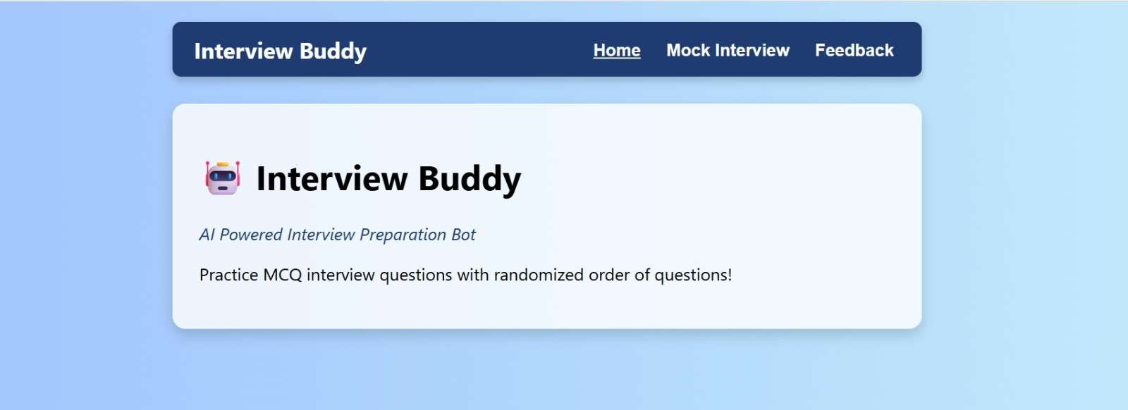

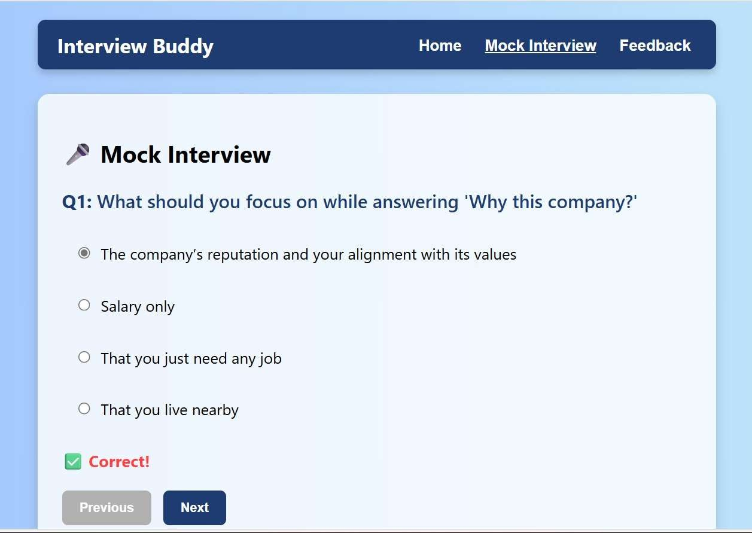

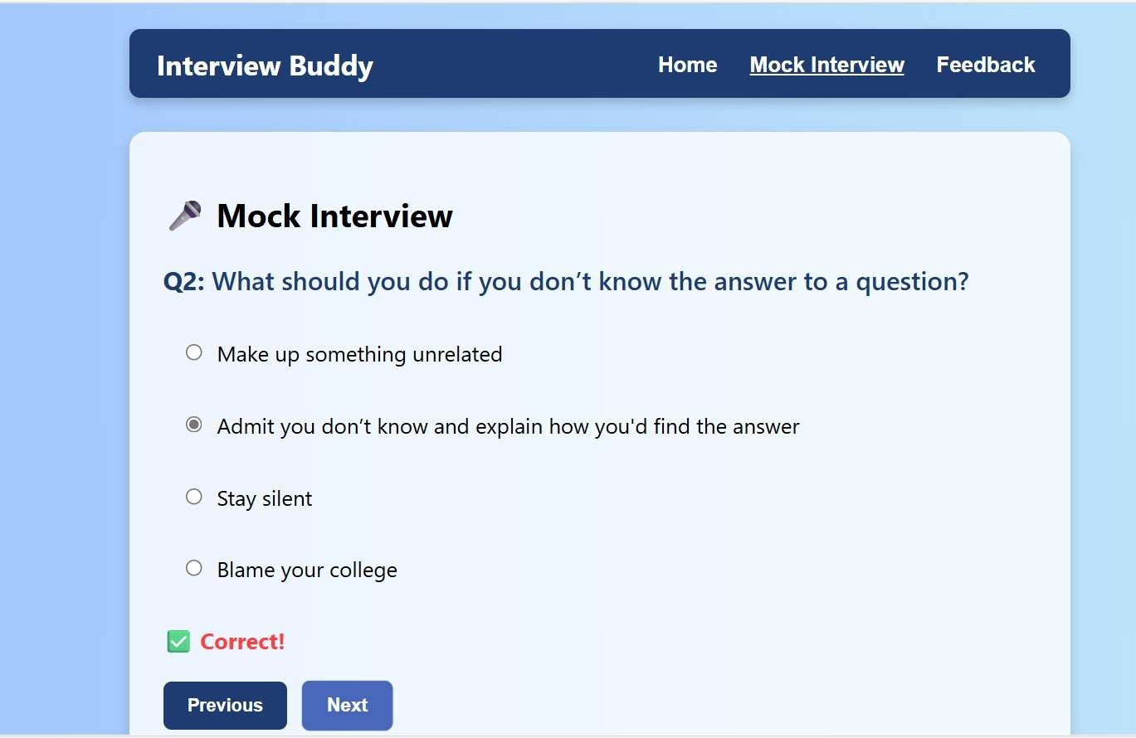

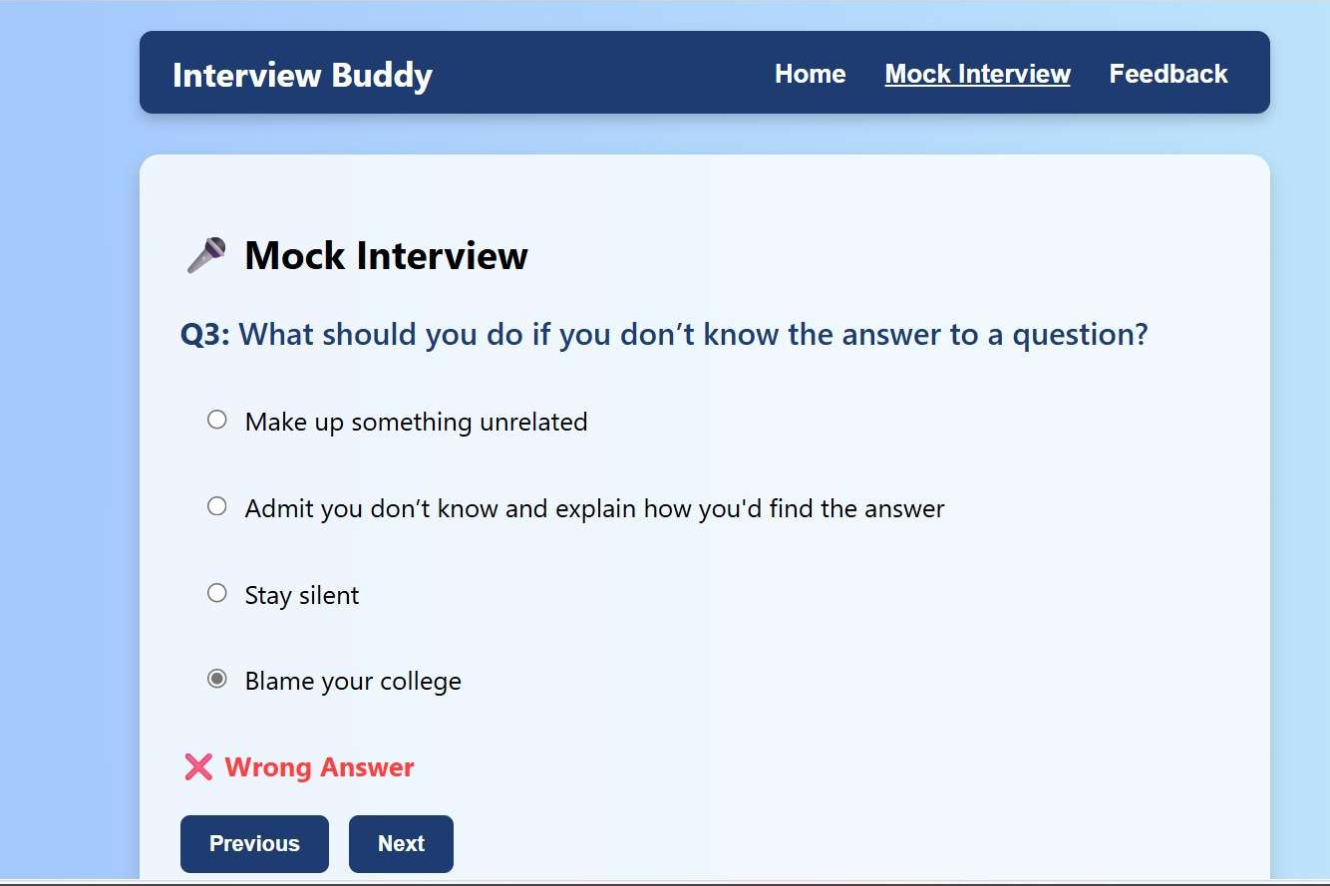

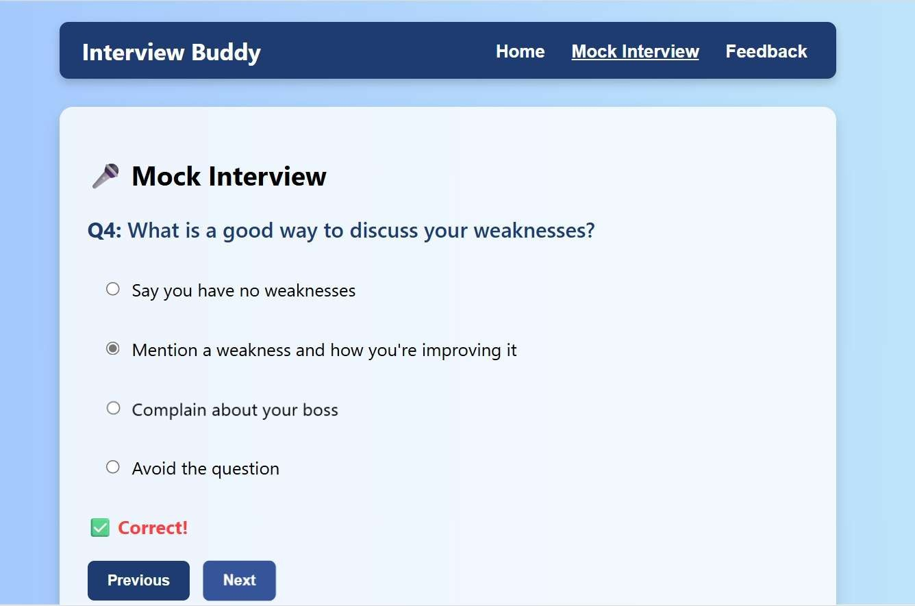

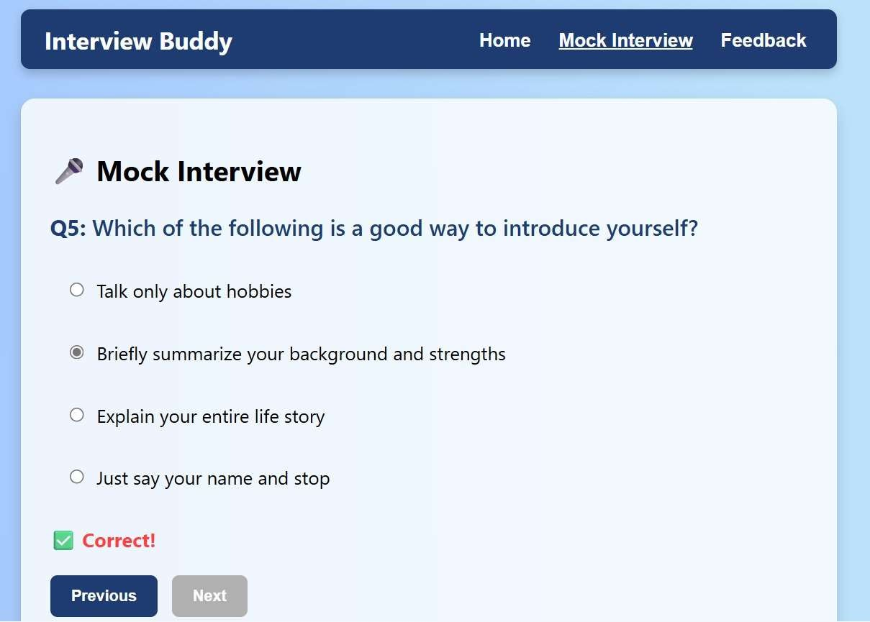

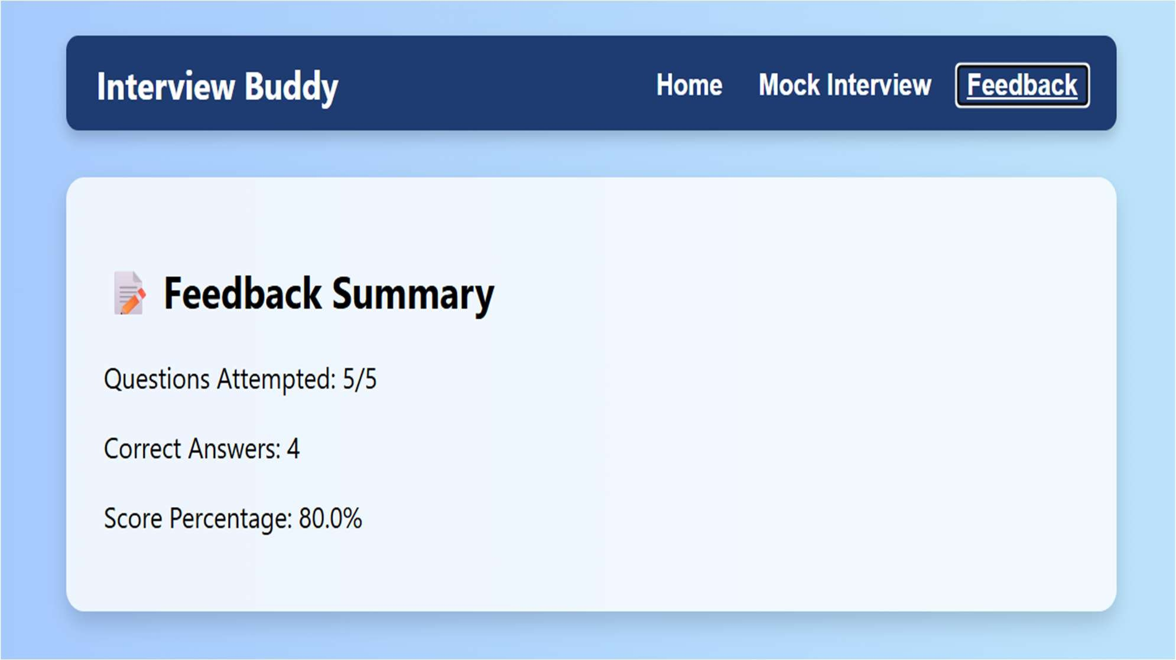

LINK:

https://github.com/priya4037/Interview-Buddy---AI-Powered-Interview-Preparation-Bot-A-Single-Page-Application-.git

